S3 Bucket – Hands On – Static Website Hosting

Step 1: Create a S3 bucket

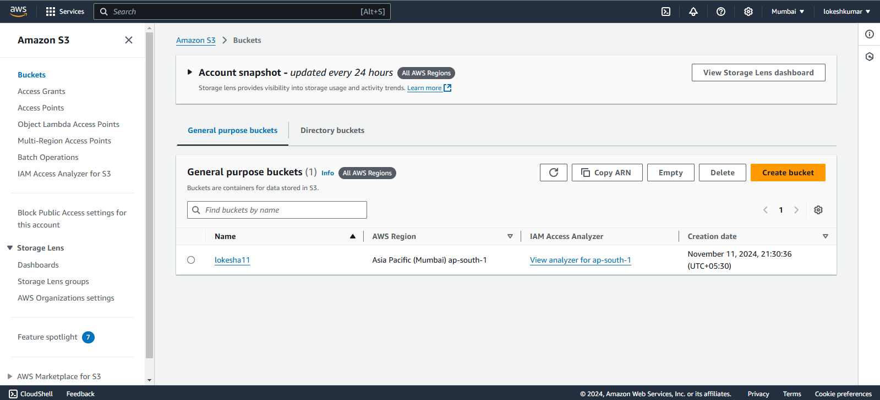

Step 2: Upload an Object

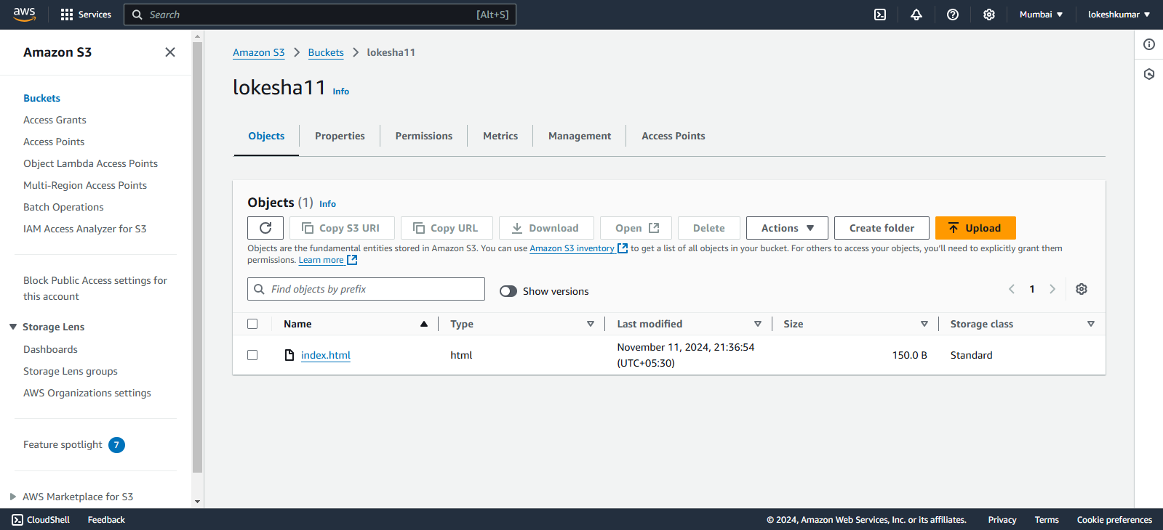

Step 3: Enable **Static website hosting**

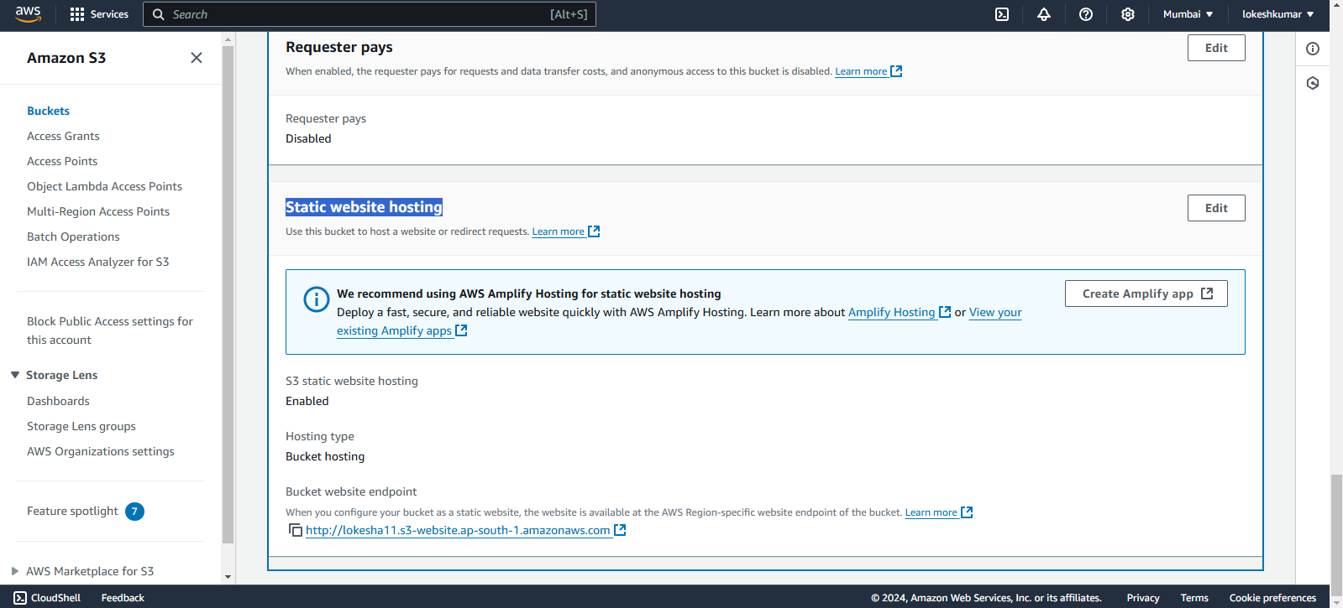

Step 4: Disable - **Block public access (bucket settings) and Create a Bucket Policy**

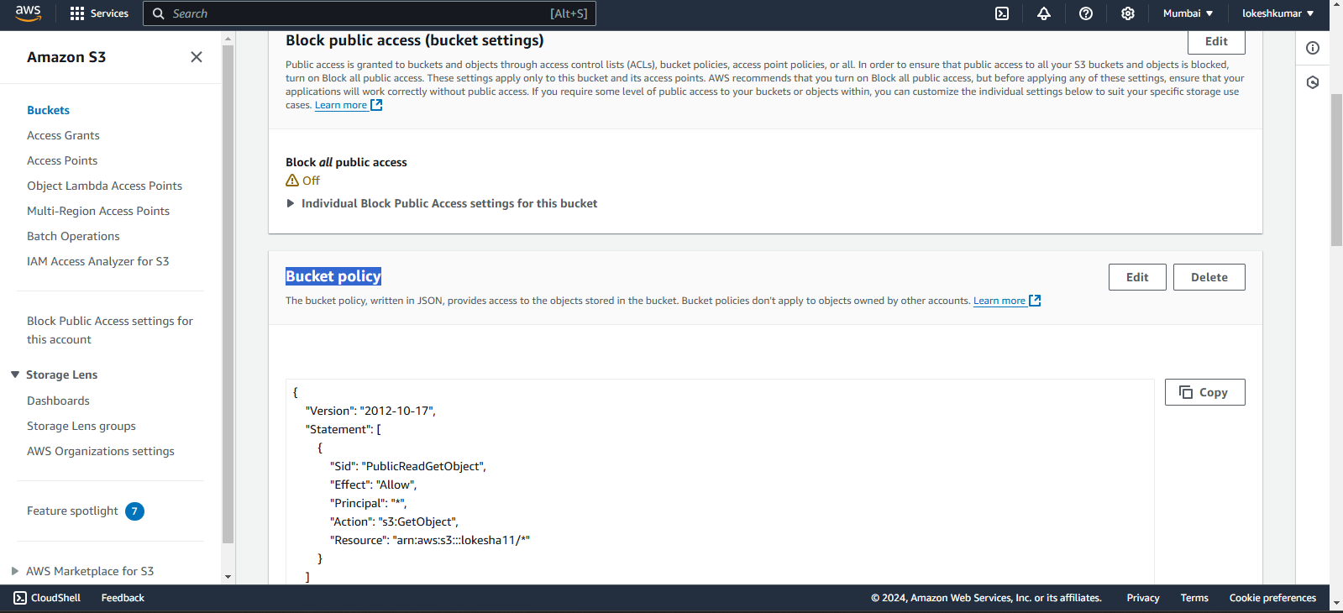

**Step 5: Output**

